ASSINGMENT – 31

To use the package with function , records , user defined datatypes in a table

To Create a table:

CREATE TABLE emplo (

employee_id NUMBER PRIMARY KEY,

first_name VARCHAR2(50),

last_name VARCHAR2(50),

salary NUMBER,

department_id NUMBER

);

Inserting values:

INSERT INTO emplo VALUES (111, 'sugin', 't', 15000, 10);

INSERT INTO emplo VALUES (112, 'lokesh', 'r', 40000, 11);

INSERT INTO emplo VALUES (113, 'senthamizh', 's',30000, 12);

INSERT INTO emplo VALUES (114, 'Monesh', 'S',50000, 13);

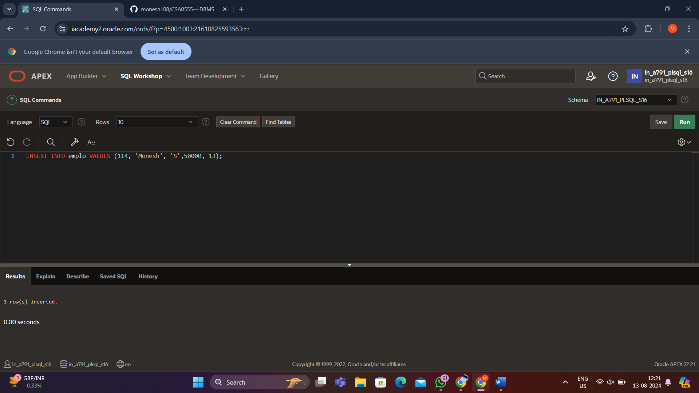

Display:

Select * from employ;

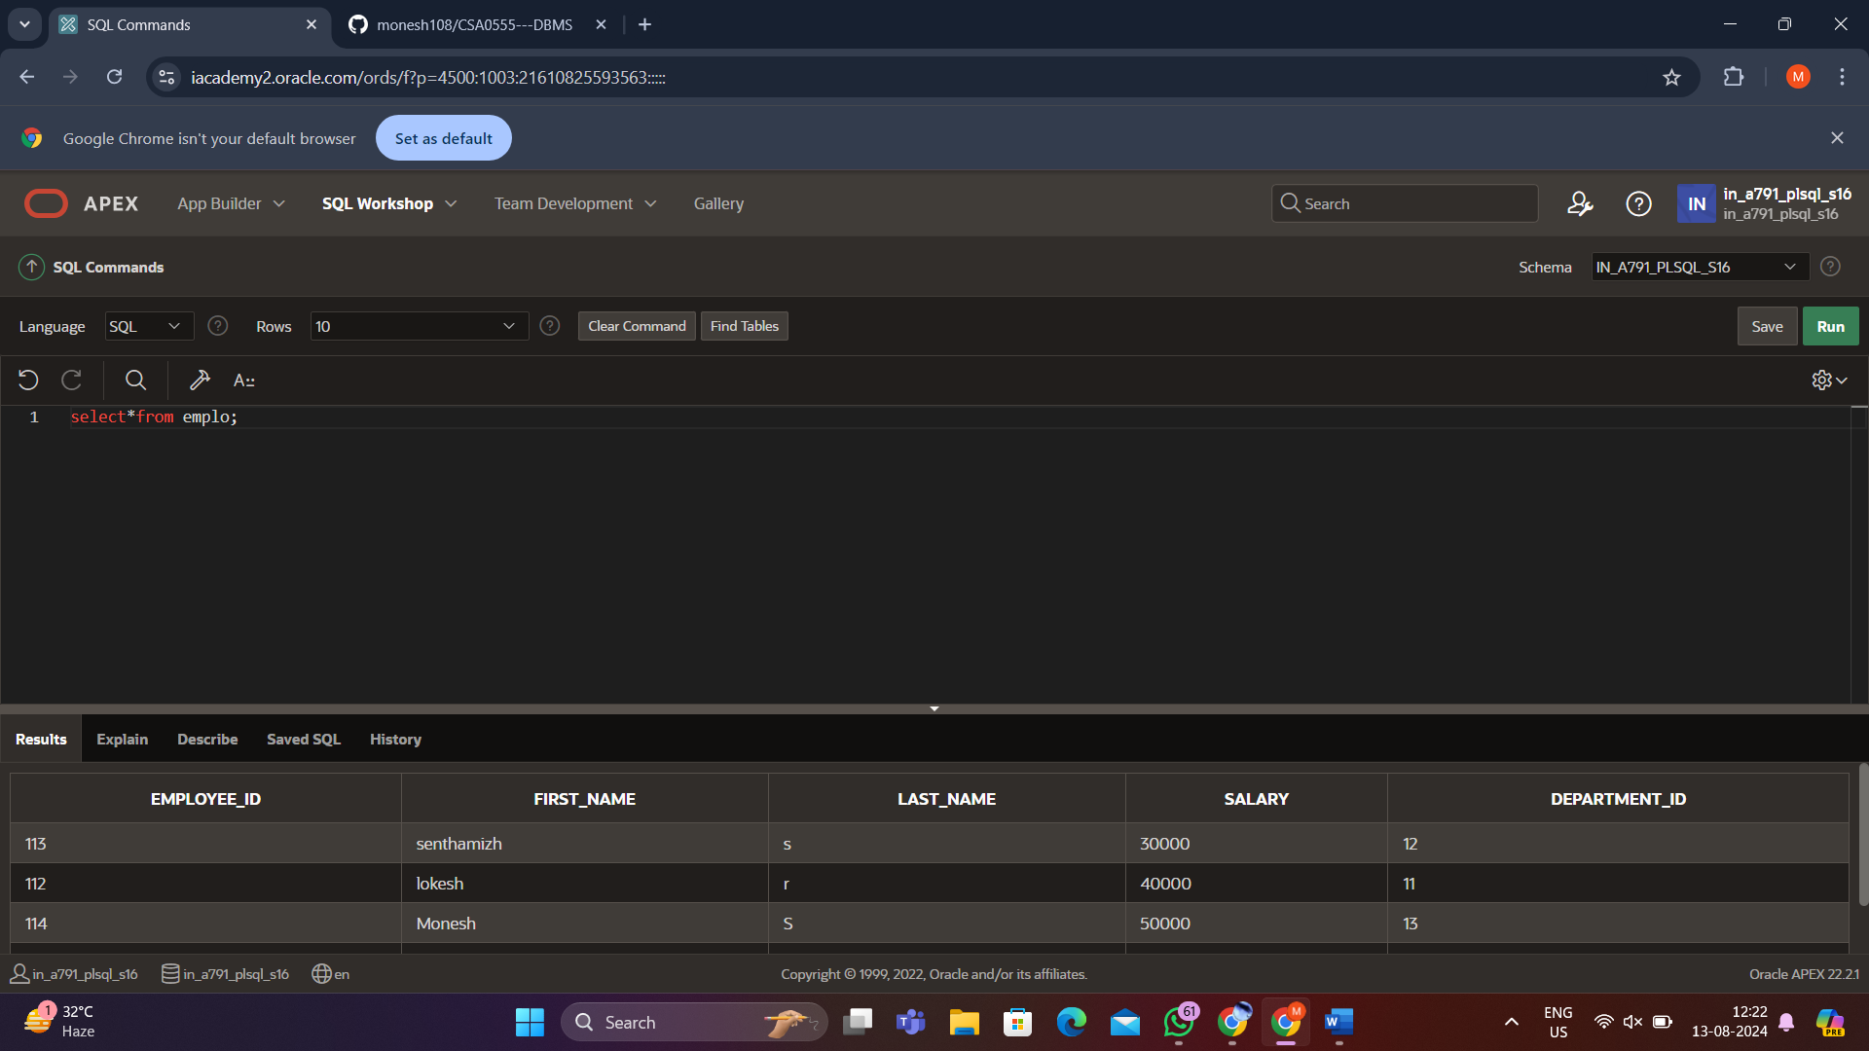

Package creation:

CREATE OR REPLACE PACKAGE employee_pkg IS

TYPE employee_rec IS RECORD (

employee_id NUMBER,

first_name VARCHAR2(50),

last_name VARCHAR2(50),

salary NUMBER

);

TYPE employee_tbl IS TABLE OF employee_rec;

FUNCTION get_employee(emp_id IN NUMBER) RETURN employee_rec;

FUNCTION get_employees_by_dept(dept_id IN NUMBER) RETURN employee_tbl;

PROCEDURE update_employee_salary(emp_id IN NUMBER, new_salary IN NUMBER);

END employee_pkg;

/

Package body creation:

CREATE OR REPLACE PACKAGE BODY employee_pkg IS

FUNCTION get_employee(emp_id IN NUMBER) RETURN employee_rec IS

emp employee_rec;

BEGIN

SELECT employee_id, first_name, last_name, salary

INTO emp

FROM emplo

WHERE employee_id = emp_id;

RETURN emp;

END get_employee;

FUNCTION get_employees_by_dept(dept_id IN NUMBER) RETURN employee_tbl IS

emp_table employee_tbl;

BEGIN

SELECT employee_id, first_name, last_name, salary

BULK COLLECT INTO emp_table

FROM emplo

WHERE department_id = dept_id;

RETURN emp_table;

END get_employees_by_dept;

PROCEDURE update_employee_salary(emp_id IN NUMBER, new_salary IN NUMBER) IS

BEGIN

UPDATE emplo

SET salary = new_salary

WHERE employee_id = emp_id;

COMMIT;

END update_employee_salary;

END employee_pkg;

/

Output:

DECLARE

emp_rec employee_pkg.employee_rec;

BEGIN

emp_rec := employee_pkg.get_employee(111);

DBMS_OUTPUT.PUT_LINE('Employee: ' || emp_rec.first_name || ' ' || emp_rec.last_name || ', Salary: ' || emp_rec.salary);

END;

/

